Introduction/Business Problem
X Investments inc. is a multinational investment firm headquartered in Y. They are constantly looking for new investment opportunities to amplify their portfolio and maximize shareholders gain. Word has reached the management team, of large scale oil discoveries in a maiden destination called Guyana. This potentially represents a lucrative market as the country is now preparing for first oil. Management has since disclosed to the research and development division that they are interested in acquiring more information about Guyana and its economy, so as to make better informed decisions about the prospect. For this they require a PESTEL analysis to be done. The PESTEL analysis will help to answer questions about the political, economic, social, technological, environmental and legal aspects of Guyana. This will identify the political stability of the nation; what are legal requirements governing the business environment ,for example, export and imports laws, local content policies among others; Currency exchange rates, the GDP trend; what are the cultural risks; what technological infrastructure is in place and is it up to the standard for the firm to conduct business and if not what needs to be put in place and the possibility of doing so; what are the geographical features and weather patterns. Taking under consideration that some executives and other company officials may need to travel to Guyana and that some may have to be there for a prolonged time, it is also necessary to gather information about features such as hospitals, restaurants, hotels, shopping districts and malls, schools, methods of transportation and other important aspects. This will help to determine if the setting is suitable for the officials and their families as required. All these aspects will help to identify the opportunities and opportunity costs and determine whether they are aligned to company goals.

Guyana is located on the north east coast of South America. Culturally, it is also part of the Caribbean and has a diverse ethnic background, as well as being a former British colony, who gained independence in 1966. This new found wealth that is creating a buzz and frenzy all over the world can drastically change the nation’s development, whose population is roughly 750,000, in a country with a land mass that extends across 83,000 square miles (215,000 square kilometers). The country is known to have various minerals for mining such as gold and bauxite, rich forest for lumbering, pristine vegetation, water resources and fauna. What does this a represent for the company? Where are lands available for mining and logging? How is the terrain of these lands? What is the feature distribution around towns and cities such as the capital Georgetown? An in-depth data analysis will help to answer these questions. Currently for this phase cidentify infrastructural features in Georgetown, such as hospitals, restaurants, hotels, shopping districts and malls, schools and other important aspects.

The specific objective will be:
To identify infrastructural features in Georgetown, such as hospitals, restaurants, hotels, shopping districts and malls, schools and other important aspects.

Data
The application will perform a “lookup” of information on schools, universities, banks, police stations, hotels, restaurants, shopping malls, night clubs, markets and hospitals. These are some important features that will be of interest to executives who will make the trip to Guyana to determine the viability of the venture.

Methodology

To determine the location data of important features the foursquare API will be used in conjunction with jupyter notebooks. More specifically the Code will be placed in jupyter notebooks which will then access the foursquare database thru it API to obtain Geo-spatial data and perform a search of venues according the specified criteria within a 500 meters radius of the Pegasus Hotel in Georgetown. The results will be plotted on a map to visualize the features which will allow for some contextual insight into the proximity of the different features from each other and how clustered there are.

Results
Map showing the distribution of features around georgetown.
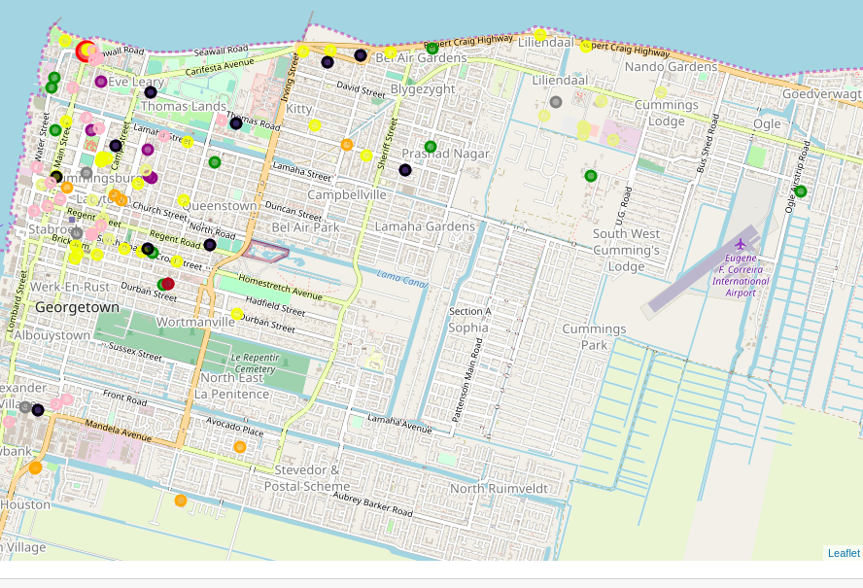

The color codes are:
Pegasus Hotel- red
Schools- orange
Restaurants- blue
Universities- green
Hotels- yellow
Police- brown
Shopping malls- khaki
Markets- grey
Night Clubs- black
Banks- pink

The results shows that there is a higher concentration of all the features within the boundaries of Hadfield street to the south, Vlisengen road to the east, Lamaha to the north and water street to the west. There are a few outliers scattered around various locations such as a few hotel along the Rupert Craig highway. The search parameter for police stations had to be changed from “police station” to “police” because it was returning results that weren’t exactly police entities.

Discussion and Recommendations
Search parameters need to be carefully considered and may require optimization to obtain the correct results as desired. Other criteria need to be considered such as the ratings of hotels, the types of restaurants such as Chinese food which is one of the famous cuisine that can be obtained in Guyana. Also, the research need to be extended to show results for other analysis such as economic and terrain specific information and culture data.

Conclusion
Based on the results obtained Georgetown has the required amenities for executives upon their visit and for a prolonged stay for those who may be required to stay for extended periods. The Pegasus hotel has a bank within very close proximity along with the other highlighted features and it is considered one of the more popular hotel in the country.

